Title: Modeling the Water Temperature Evolution of Ice-Covered Lakes
Abstract
Accurate modeling of water temperature of ice-covered lakes vary with depth is critical for predicting the movement of phytoplankton and nutrients driven by solar-powered water motion. As light is allowed to propagate through the ice, it is absorbed and heats the near-ice water increasing both the temperature and density of cold water to form a mixing layer underneath the ice. The goal is to create a user-friendly webpage to allow users to change external parameters such as solar intensity and ice composition, along with lake characteristics such as depth and water clarity, to predict the onset of this mixing. Utilizing advanced mathematics, the webpage will be built using Python, then with an easy-to-use graphical interface (GUI) to observe the evolution of the water temperature and to predict the onset of solar-powered mixing.
Introduction
In winter, many lakes in the northern hemisphere (e.g. Great Lakes region) freeze over. However, they are not dormant, as they become hot spots for recreation (e.g. ice fishing) as well as biological (e.g. phytoplankton) and physical processes (e.g. water motion) (Jansen et al, 2021). These often influence one another, for example Radiatively Driven Convection (RDC) can result from sunlight penetrating through the ice. Heating water near the ice leads to convective plumes and mixing as increasing water temperatures below $4℃$ increasing water density. This mixing creates a mechanism that transports phytoplankton to the surface of the lake therefore sometimes resulting in blooms (Smith et al, 2025). A recent study by Smith et al (2025) found that the onset of RDC could be predicted by analyzing the evolution of the temperature profile. Using high resolution computer simulations, they provide an equation that reasonably predicts the onset of RDC which could be used to gather information about what will happen in the ecosystem beneath. Current prediction models used for this purpose require extensive knowledge of advanced mathematics and physics, making it difficult for public to approach and interpret their results. The goal of this project is to predict the onset of RDC from temperature profiles with an easy-to-use graphical interface that is easy to understand.
Ice-covered lakes have been studied for a very long time, with scientific interest dating as early as the nineteenth century, then starting to gain more traction towards the end of the twentieth century (Sharma et al 2024). Recent interest has stemmed from a lack of understanding of winter periods that were historically overlooked due to adverse conditions including RDC (Jansen et al 2021). The first observations of RDC include Farmer (1975), who, by explicitly including solar radiation in mathematical models, were among the first to make the connection between RDC and the under-ice water temperature profile.
The key focus is to observe different techniques used to draw connections between RDC and temperature profiles associated with ice-covered lakes. One of the biggest tools used to study lakes is the use of computational simulations or computational fluid dynamics (CFD). The first issue with CFD is the large barrier to entry since it requires knowledge of fluid dynamics and advanced mathematics. Additionally, iit requires a significant amount of computational resources such as memory and time meaning that CFD can be very costly and less accessible (Allum et al, 2024). Another approach is to do field experiments to collect physical samples and measurements. Although enlightening, it will be specific to the lake that you are collecting data from (e.g. see Bouffard et al 2019 for Lake Baikal). Additionally, it can take a long time to collect and analyze the data as well as being expensive to obtain the equipment to carry out the campaign. Overall, these different techniques are very useful in their own ways, however, they have a common denominator: they are expensive and difficult to obtain without specialized knowledge.
Our proposed solution will be significantly cheaper and more accessible. Over the last academic year, we have developed a prototype. This prototype is based on the ice model from Smith (2025), which Is used to simulation ice attenuation. The user can input different lake parameters. For example, they can change the max depth of the lake $z_{0}$, how fast the temperature of the water will decrease with depth (thermocline temperature) $T_{H}$, the depth of the thermocline i.e. the region of the lake that experiences this temperature fluctuation $H$, and how well light permeates through white $k_w$ and black ice $k_b$ (ice attenuation). This generates a base graph for the temperature profile with at an initial time $t=0$. Utilizing slider, the user input a max time and drag the slider to see how the temperature will change with depth over time. The user can also change the white ice proportion (ratio of white ice to black ice) $p$ via a slider, which will decrease the initial change in temperature in the water. Refer to Table 1 for a more in-depth synopsis. We then test this model against Matthews and Heaney (1987) to determine accuracy.
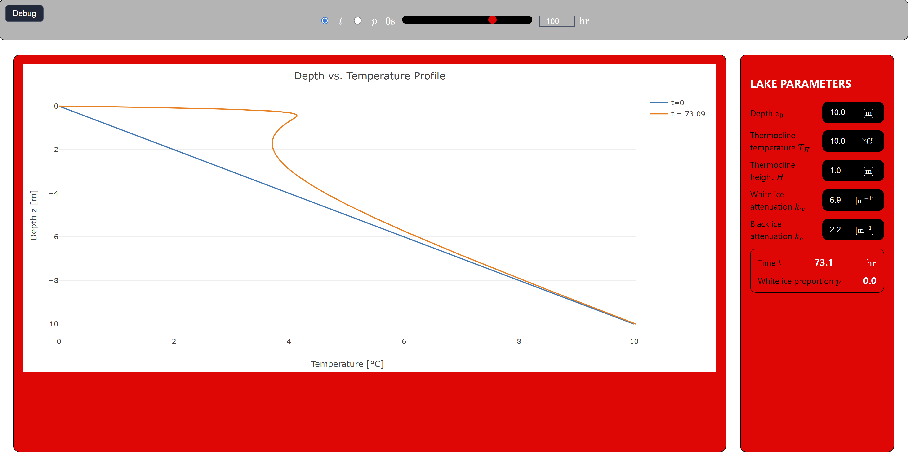
Figure 1: Our current model that plots the solution to the 1D solar forcing heat equation.
There is already a large variety of software that models water temperature to varying degrees of complexity. For example, there is a GitHub repository that uses the language R to model temperature dynamics in lakes based on the one-dimensional integral energy model. This model achieves something similar to what we are creating, however, since it is programmed in R, the user is limited to how it can access the package. The user can also be limited by programming knowledge, as using this package required knowledge of the statistical language R. Additionally, the set-up process is not very intuitive or accessible on its own. Our program is based off Smith et al 2025 where a model is developed to predict RDC in ice-covered lakes. This model combines the heat equation with solar forcing and ice-proportions to accurately measure the temperature due to solar forcing (Smith et al 2025). The equation incorporates ice attenuation which is an experimentally determined constants that tells use how much of the solar forcing will penetrate through the ice.
Research Questions and Objectives
In this research, our goal is to answer the following questions and goals; (1) Can we create a general model of the evolution of the temperature in ice-covered lakes for any general lake? As we’ve discussed, most currently existing models are based around data from one lake, which means that the data cannot be generalized to any ice-covered lake. (2) Incorporate a user input for the user to upload a temperature profile for any lake. Building off the previous question 1, we want to implement a way to have a database of lakes, each user building off of each other. Not only does it create a more universal program, but we can use it to gather data to make our simulation more accurate, especially when it comes to experimentally determined ice attenuations. (3) To predict when RDC begins just from user input data. Based on the current prototype, we can simulate the region where the temperature has its most variation, so we can implement what we know about RDC to create a part of the program that can predict its onset. (4) Can limnologists use this model in their practice sufficiently? One of the main goals besides the general public’s use, is more specifically for limnologists to uise this program to predict the onset of phytoplankton blooms. So, we can add different optional markers on the graph, based on the users useage, to create a more tailored experience.
Methods
An interactive web-model will be created using Python, JavaScript, HTML, and CSS. In the base model, we have already implemented the solar-forced heat equation (Matthews and Heaney 1987) using the parameters described in Table 1. However, our target goal is to incorporate field data to make accurate predictions for the onset of convective bloom. We will achieve this by incorporating the ice model of Smith (2025) to simulate the light attenuation by the ice cover.
Variable | Name
$$z_{0}$$ | Depth
$$T_{H}$$ | Thermocline temperature
$$H$$ | Thermocline height
$$k_{w},k_{b}$$ | White\black ice attenuation; how much radiation can penetrate the ice; determined experimentally
$$p$$ | White ice proportion
$$λ$$ | Clarity
$$κ$$ | Diffusivity
$$I_{0}$$ | Solar forcing; function of $p$
$$I_{S}$$ | Solar irradiance; initial solar radiation due to the sun
$$α$$ | Surface albedo; how much solar radiation is reflected
Table 1: the parameters for the model and what they mean
Where each variable will be able to be inputted by the user and implemented into the GUI without needing to consider mathematics or programming. The solution will be plotted as a curve to demonstrate the evolution of the temperature of the lake as you increase in depth within a lake. After the model is implemented, we can collect data from Lake Mendota, Madison, WI. This data will be compared to the model developed to determine accuracy. Our end goal is to have a way for the user to upload their own data (e.g. .csv format) and interpolate that onto a function that’s used by the code.
Timeline (Gantt Chart)
Figure 2 shows the timeline for the proposed project in the form of a Gantt chart over the course of the summer. The first two weeks will be spend researching the how to interpolate data to a function based on user-uploads. Additionally, this will transition into planning on different methods. Then, the majority of the summer would be spent implementing these changes and testing.
 | Week 1 |  | Week 2 |  | Week 3 |  | Week 4 |  | Week 5 |  | Week 6 |  | Week 7 |  | Week 8
Planning
Research
Implementation
Follow-up
Figure 2: Gantt chart showing the timeline of the proposed project.
Conclusion
Creating a concise and simple approach to modeling the solar-forcing heat equation will allow anyone with access to the internet to model the evolution of temperature in ice-covered lakes and to be used to predict RDC. Researchers can implement this simulation to better predict the level of safety of ice for recreation. Additionally, limnologists can use this to gain better context on the movement of algae and phytoplankton. As we’ve explored, we can use algae and other small forms of life to help us study climate change better.
References
Bouffard, Damien, and Alfred Wüest. “Convection in Lakes.” Annual Review of Fluid Mechanics, vol. 51, no. 1, Jan. 2019, pp. 189–215. DOI.org (Crossref), https://doi.org/10.1146/annurev-fluid-010518-040506.
Bouillaut, Vincent, et al. “Transition to the Ultimate Regime in a Radiatively Driven Convection Experiment.” Journal of Fluid Mechanics, vol. 861, Feb. 2019, p. R5. DOI.org (Crossref), https://doi.org/10.1017/jfm.2018.972.
Brown, Laura C., and Claude R. Duguay. “The Response and Role of Ice Cover in Lake-Climate Interactions.” Progress in Physical Geography: Earth and Environment, vol. 34, no. 5, Oct. 2010, pp. 671–704. DOI.org (Crossref), https://doi.org/10.1177/0309133310375653.
Culpepper, Joshua, et al. “Lake Ice Quality in a Warming World.” Nature Reviews Earth & Environment, vol. 5, no. 10, Sept. 2024, pp. 671–85. DOI.org (Crossref), https://doi.org/10.1038/s43017-024-00590-6.
Duguay, Claude R., et al. “Ice‐cover Variability on Shallow Lakes at High Latitudes: Model Simulations and Observations.” Hydrological Processes, vol. 17, no. 17, Dec. 2003, pp. 3465–83. DOI.org (Crossref), https://doi.org/10.1002/hyp.1394.
Farmer, David M. “Penetrative Convection in the Absence of Mean Shear.” Quarterly Journal of the Royal Meteorological Society, vol. 101, no. 430, Oct. 1975, pp. 869–91. DOI.org (Crossref), https://doi.org/10.1002/qj.49710143011.
Hadjerci, Gabriel, et al. “Radiatively Driven Convection: Diffusivity-Free Regimes of Geophysical and Astrophysical Flows in the Laboratory.” Comptes Rendus. Physique, vol. 25, no. S3, June 2025, pp. 5–20. DOI.org (Crossref), https://doi.org/10.5802/crphys.207.
Jansen, Joachim, et al. “Winter Limnology: How Do Hydrodynamics and Biogeochemistry Shape Ecosystems Under Ice?” Journal of Geophysical Research: Biogeosciences, vol. 126, no. 6, June 2021, p. e2020JG006237. DOI.org (Crossref), https://doi.org/10.1029/2020JG006237.
Jonas, Tobias, et al. “Radiatively Driven Convection in an Ice‐covered Lake Investigated by Using Temperature Microstructure Technique.” Journal of Geophysical Research: Oceans, vol. 108, no. C6, June 2003, p. 2002JC001316. DOI.org (Crossref), https://doi.org/10.1029/2002JC001316.
Kirillin, Georgiy, et al. “Physics of Seasonally Ice-Covered Lakes: A Review.” Aquatic Sciences, vol. 74, no. 4, Oct. 2012, pp. 659–82. DOI.org (Crossref), https://doi.org/10.1007/s00027-012-0279-y.
Ladwig, Robert. LakeModelR. R. 2002, https://github.com/robertladwig/LakeModelR/tree/main.
Lepot, Simon, et al. “Radiative Heating Achieves the Ultimate Regime of Thermal Convection.” Proceedings of the National Academy of Sciences, vol. 115, no. 36, Sept. 2018, pp. 8937–41. DOI.org (Crossref), https://doi.org/10.1073/pnas.1806823115.
Matthews, P. C., and S. I. Heaney. “Solar Heating and Its Influence on Mixing in Ice‐covered Lakes.” Freshwater Biology, vol. 18, no. 1, Aug. 1987, pp. 135–49. DOI.org (Crossref), https://doi.org/10.1111/j.1365-2427.1987.tb01302.x.
Mironov, Dmitrii, et al. “Radiatively Driven Convection in Ice‐covered Lakes: Observations, Scaling, and a Mixed Layer Model.” Journal of Geophysical Research: Oceans, vol. 107, no. C4, Apr. 2002. DOI.org (Crossref), https://doi.org/10.1029/2001JC000892.
Schaefer-Rolffs, Urs, and Erich Becker. “Horizontal Momentum Diffusion in GCMs Using the Dynamic Smagorinsky Model.” Monthly Weather Review, vol. 141, no. 3, Mar. 2013, pp. 887–99. DOI.org (Crossref), https://doi.org/10.1175/MWR-D-12-00101.1.
Sharma, S., et al. “Lake Ice From Historical Records to Contemporary Science.” Journal of Geophysical Research: Biogeosciences, vol. 129, no. 4, Apr. 2024, p. e2023JG007670. DOI.org (Crossref), https://doi.org/10.1029/2023JG007670.
Smith, Benjamin J., et al. “How Ice Composition Controls Radiatively Driven Convection Under Lake Ice.” Geophysical Research Letters, vol. 52, no. 19, Oct. 2025, p. e2025GL117454. DOI.org (Crossref), https://doi.org/10.1029/2025GL117454.

